Lab 3: Smart Resource Allocation and Scheduling System using Greedy Algorithms
Question 2: Visualizations and Performance Graphs
Field | Details
Name | [sohail khan]
Roll No. | [2401201080]
Specialisation | [BCA AI DS]
Section | [B]
Lab Name | Lab 3

1. Resource Allocation Chart
Interval Partitioning assigns every task to the fewest resources. The Gantt-style chart shows 6 resources are needed for the 11 sample tasks, equal to the maximum number of tasks overlapping at any instant.
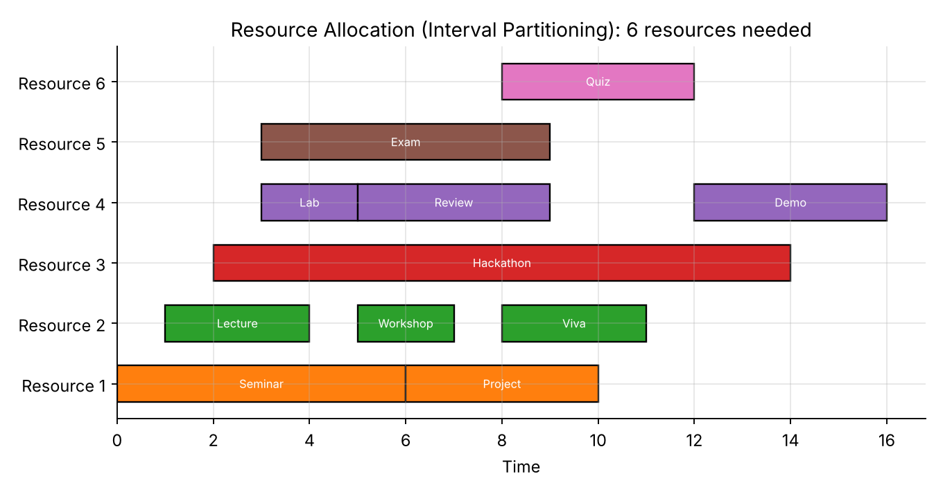
Figure 1: Resource allocation across 6 resources

2. Activity Timeline
Activity Selection picks the earliest-finishing compatible activity each time. Green bars are the 4 chosen activities (Lecture, Workshop, Viva, Demo); grey bars were rejected for overlap.
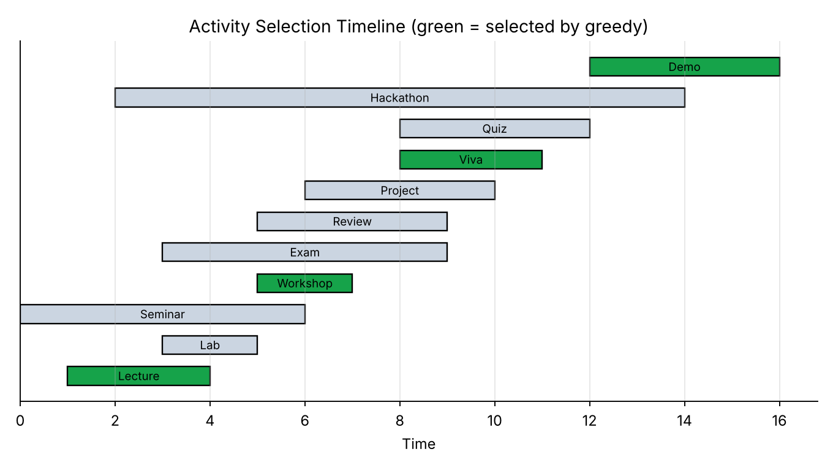
Figure 2: Activity selection timeline

3. Huffman Tree Representation
Huffman tree built for the text "smart resource allocation and scheduling". Left edges are 0, right edges are 1. The encoded message uses 157 bits instead of 320 bits (about 51% smaller) and decodes back to the original text.
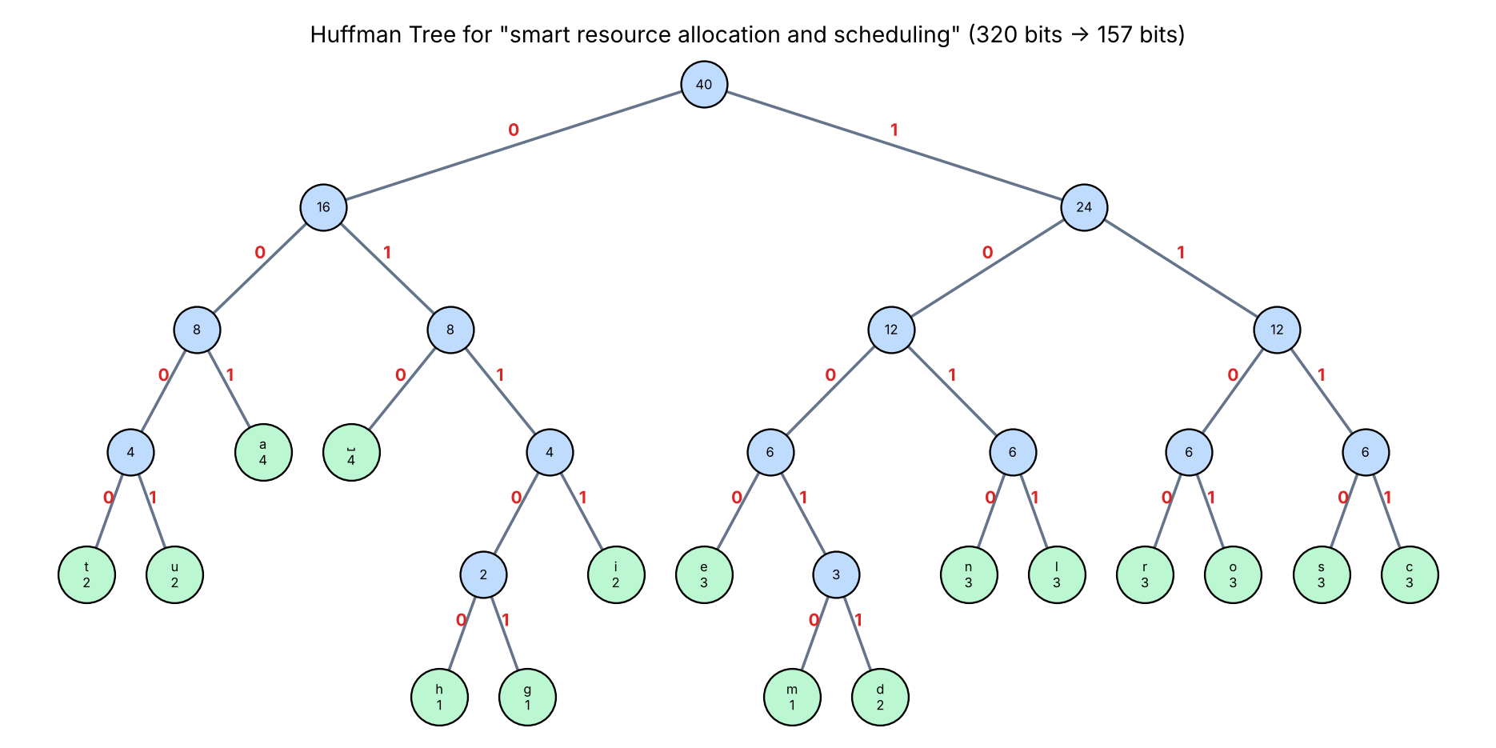
Figure 3: Huffman tree with edge labels and frequencies

4. Fractional Knapsack and Job Sequencing
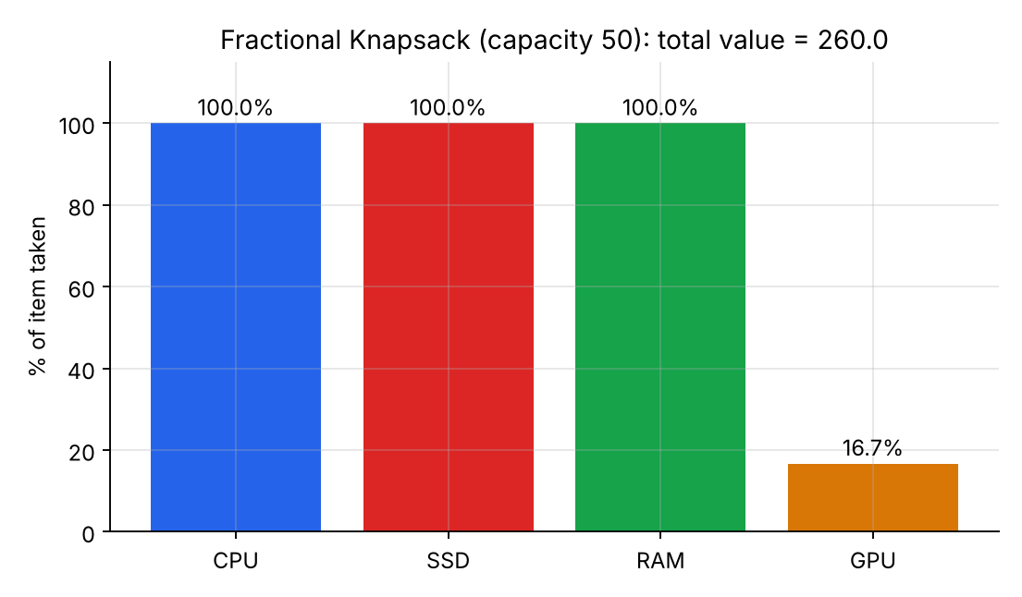
Figure 4: Fractional knapsack (capacity 50), total value 260
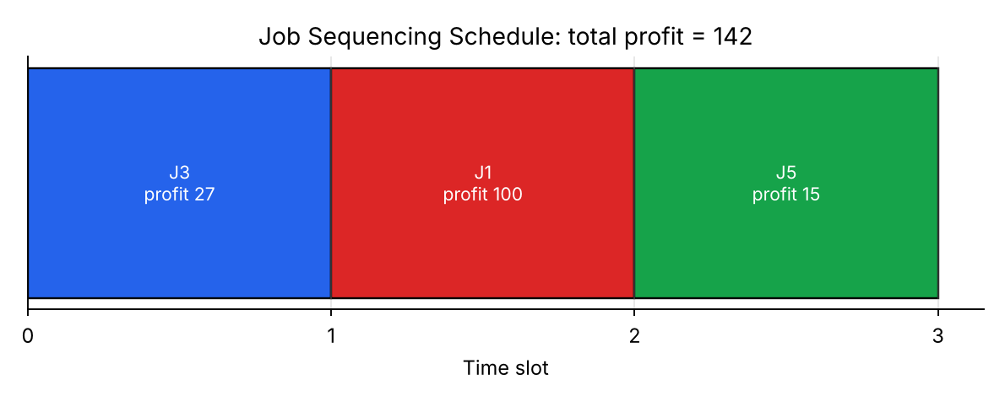
Figure 5: Job sequencing schedule, total profit 142

5. Performance Graphs
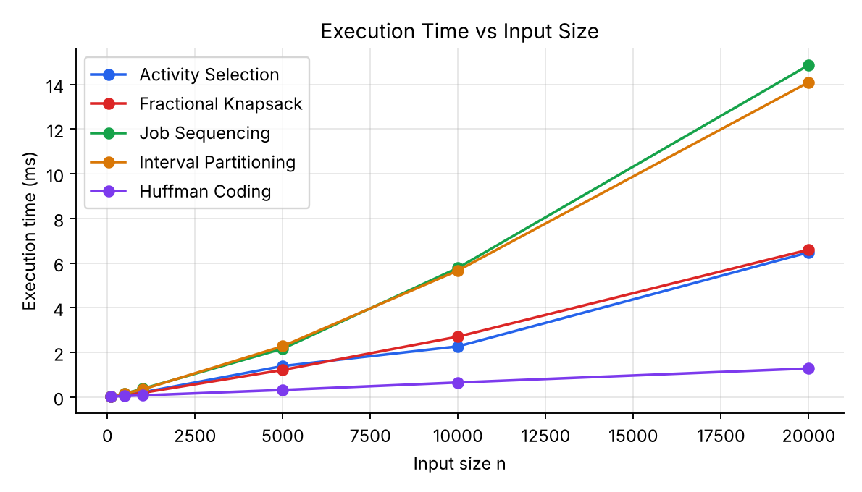
Figure 6: Execution time vs input size
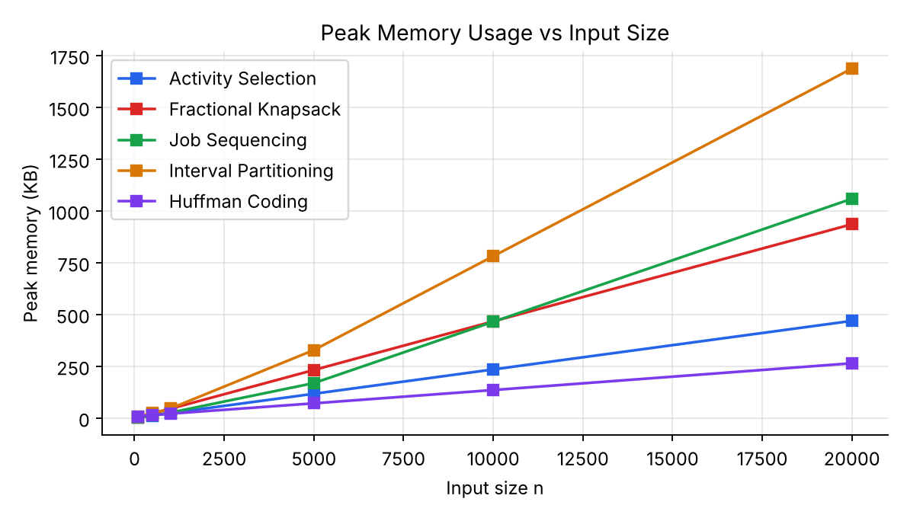
Figure 7: Peak memory vs input size
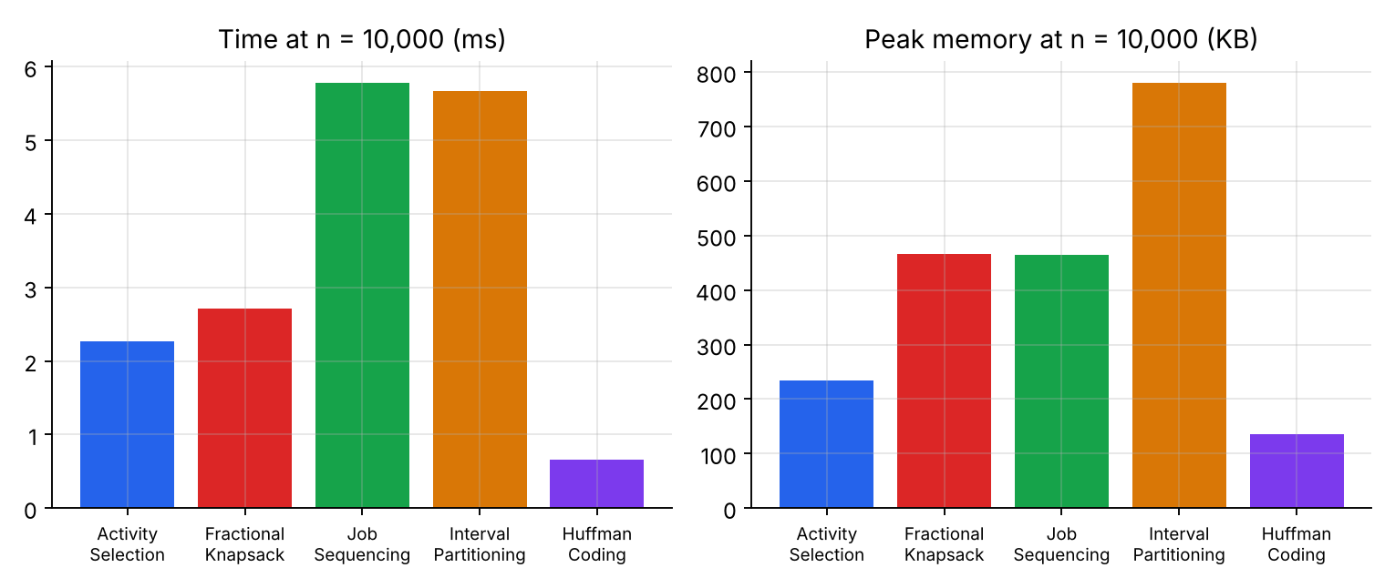
Figure 8: Time and memory comparison at n = 10,000

6. Interpretation
All curves grow roughly linearly on the log-linear scale expected for O(n log n) algorithms. Interval Partitioning and Job Sequencing cost the most because of the extra heap and union-find structures, while Huffman Coding stays cheapest since its tree size depends on alphabet size, not text length.

